**PhameratorNexusBuilder**

I. Description

This is a program designed to help Phamerator users quickly and easily create phylogenetic dendrograms in Splitstree4 ([www.splitstree.org/](http://www.splitstree.org/)). It bridges the gap between these two programs by extracting pham data for the selected genomes in a local Phamerator database, and puts them into a Nexus file, which is one of the supported input formats for Splitstree4.

Early versions of this program were command line-only, and were not very user-friendly. Newer versions (including this one) improves on the initial program by running in a minimal graphical user interface (GUI), and including additional run modes.

The program works on MacOS and Linux operating systems where Python3 is installed. The MacOS version is available as a standalone application, as is the Linux version, but the source code is also available so that if the application bundles don’t work properly on your machine, you are not excluded from using the program.

II. Dependencies

PhameratorNexusBuilder is available either as a standalone application on MacOS, or as source code that can be run on either MacOS or Linux (tested on Ubuntu, but likely works without issue on other distributions). To run from source requires that users have Python 3.5 or higher installed on their machine. Because the program interacts with Phamerator databases, which use MySQL, some version of MySQL must also be installed on your machine (5.7 and 8.0 have been tested extensively). This is true whether you use the standalone application or the source package. In addition, there is no native Python module to interact with MySQL, therefore the pymysql module must be installed.

You can check to see if you have Python 3 installed by opening a Terminal window and typing “python3 --version”. The result will either be your version of Python 3, if it is installed on your machine, or “-bash: python3: command not found” if Python 3 is not installed.

To install Python 3 on MacOS, go to <https://www.python.org/downloads/>, and download a Python release >= 3.5.1. This will download a Python 3 installer package, which if executed will install Python 3 if it isn’t installed on your machine, or upgrade the existing Python 3 version if an older one is present.

To install Python 3 on Ubuntu, open a Terminal and type “sudo apt-get install python3”, and enter your password. If it already exists and is up-to-date, the aptitude installer will notify you of this. If it exists but needs an upgrade, it will tell you that. If it doesn’t exist, you can choose to install it, and follow the prompts to do so.

Once Python is installed, in order to be able to use PhameratorNexusBuilder with your MySQL databases, you’ll need to install pymysql. This can be accomplished from the Terminal using the following command: “sudo pip3 install pymysql”. On Ubuntu this can also be done by using the aptitude installer with “sudo apt-get install python3-pymysql”

You should now be ready to go.

III. Guided Example on a Computer with MacOS

Suppose you want to generate a Splitstree diagram to view the relationships among all the Microbacterium phages present in the Hatfull Lab’s Actino_Draft database. Upon launching PhameratorNexusBuilder, you would select the first option “Retrieve phams from selected Hosts”.

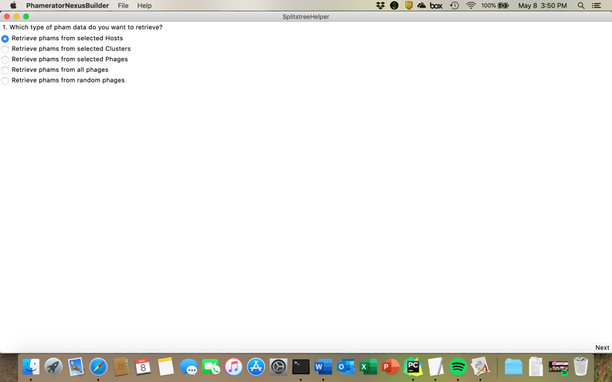

After clicking “Next”, you’ll be prompted to choose a database to pull the data from. If you only have Actino_Draft, this will be your only option. Users with more databases will have to use their judgment to select only an up-to-date Phamerator database.



Clicking “Next” will bring you to a window asking you to choose which Host(s) you’d like to compare phages from. Click on Microbacterium in the “Available Hosts” field, then click the button that says “Add to Selection >>”. If you add the wrong host(s) to the list, you may click on their names in the “Selected Hosts” field, then click the button that says “<< Remove from Selection” to remove them from your selection.



Clicking “Make Nexus File” will prompt you for a filename and location for the Nexus file. You will also be prompted when the Nexus file is done being written.

Periodically, the program will be updated - you can check whether updates are available by clicking Help > Check for Updates. If you encounter a bug, you can report it to Christian at [chg60@pitt.edu](mailto:chg60@pitt.edu). To quit the program, click File > Quit, use keyboard shortcuts, or click the little red x button like you might close any other application.